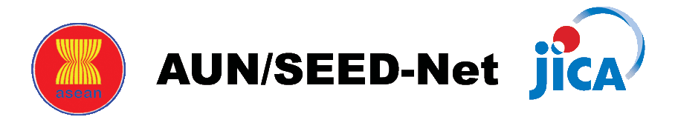
ASEAN University Network/ Southeast Asia Engineering Education Development Network

Photo
(Taken within
the past 6 months)
APPLICATION FORM
Intensive Course on Management of Technology 2017
Part ONE

1 | Applicant’s Personal Information
 | Family Name
 | Given Name(s)
 | Current Position
 | Academic Title
 | Department/ Faculty
 | University
 | Email
 | Age

2 | Please describe why you are interested in Intensive Course on Management of Technology and how it could be useful for your research as well as how you can disseminate the knowledge and contribute to your university/institution after the training: max. of 800 words

3 | Declaration
I declare that all information supplied in this application as well as the attached documents are true and correct to the best of my knowledge.
Applicant
Name:
Signature:
Date:

END of Application Part ONE

